
PRACTICAL-02

AIM: To implementation and time analysis of linear and binary search algorithm.

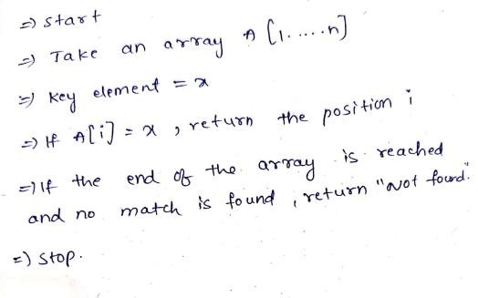
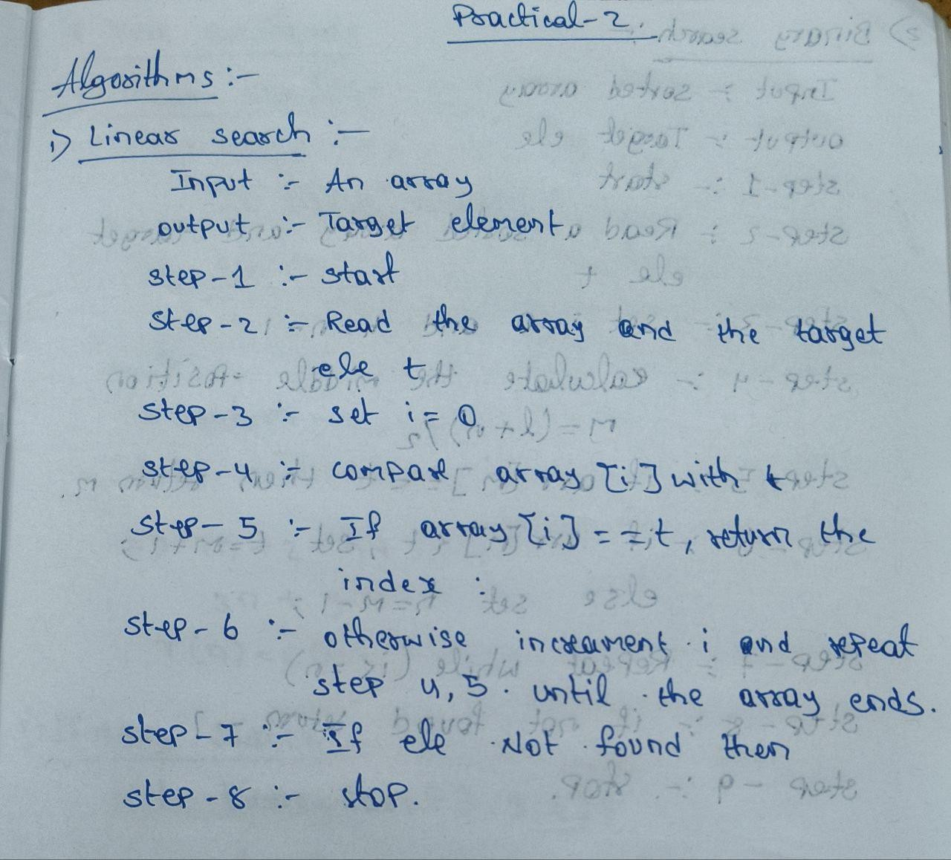

LINEAR SEARCH ALGORITHM:

PROGRAM:
#include <iostream> using namespace std;
int main() {
int arr[100],i,n,key;
cout<<"enter number of array elements:"<<endl; cin>>n; cout<<"enter array elements:"<<endl;
for(i=0;i<n;i++){ cin>>arr[i];

}
cout<<"enter element to serach:"<<endl; cin>>key;
for(i=0;i<n;i++){

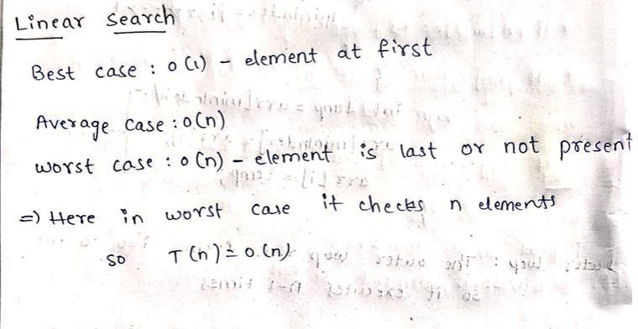
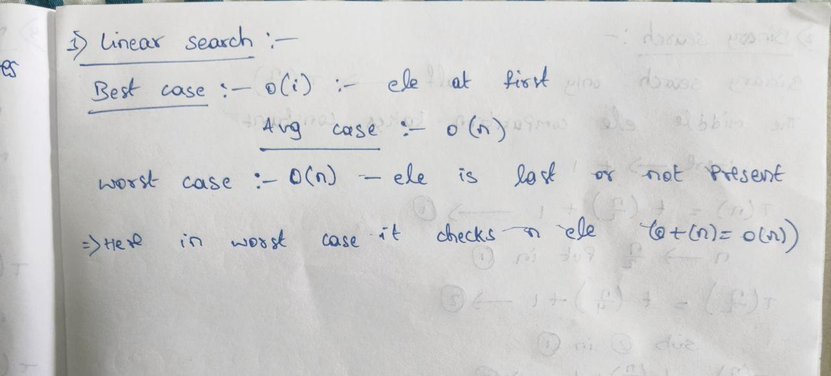


if(arr[i]==key)
{
cout<<"element found at index of:"<<i;
}

}

return 0;
}

OUTPUT:
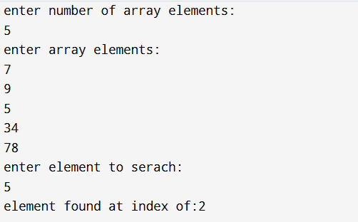

TIME COMPLEXITY:


- BINARY SEARCH ALGORITHM:
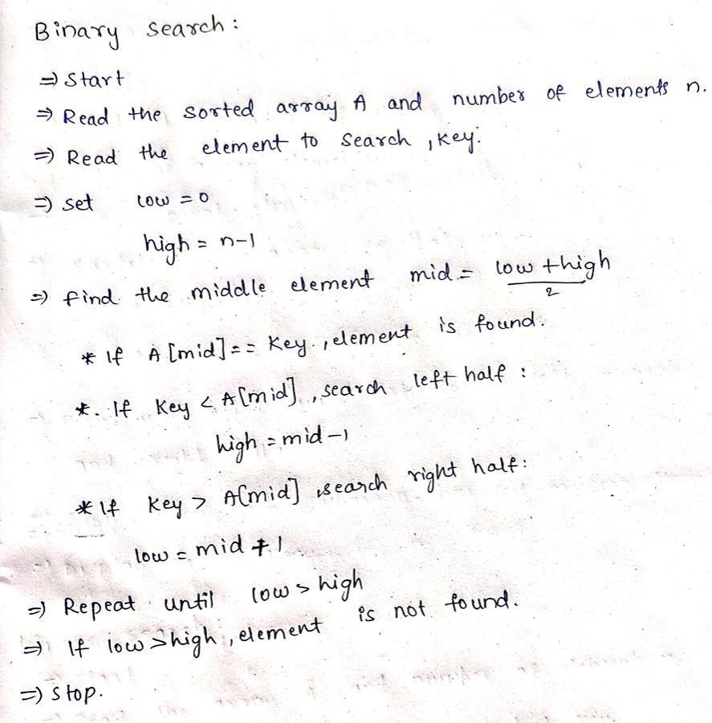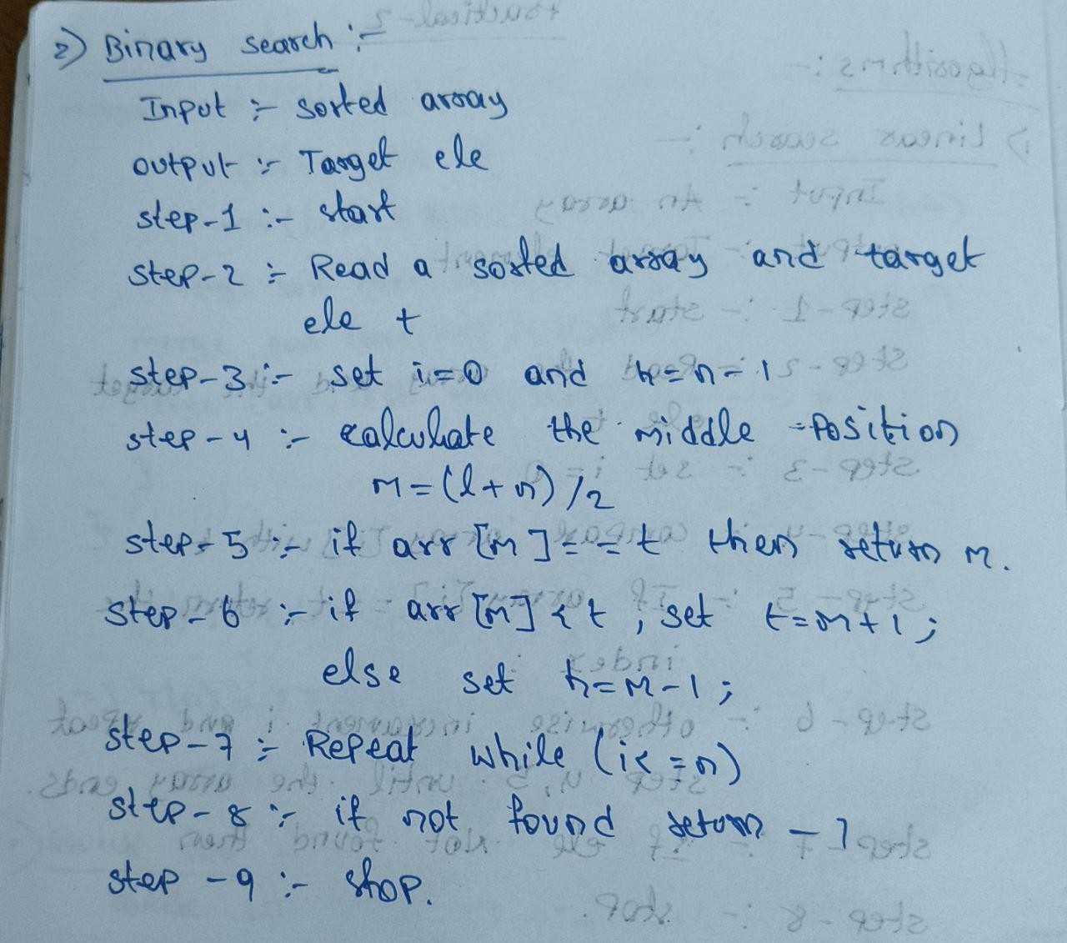

PROGRAM:
#include <iostream> using namespace std;

void bubblesort(int arr[], int n) { for(int i=0; i<n-1; i++) {
for(int j=0; j<n-i-1; j++) { if(arr[j] > arr[j+1]) {
int temp = arr[j]; arr[j] = arr[j+1]; arr[j+1] = temp;


}
}
}
}
int binarySearch(int arr[], int n, int key) { int low = 0, high = n-1;
while(low <= high) {
int mid = (low + high) / 2; if(arr[mid] == key) return mid;
else if(arr[mid] < key) low = mid+1; else high = mid-1;
}
return -1;
}

int main() {
int arr[100], n, key;
cout << "Enter number of array elements: "; cin
>> n;

cout << "Enter array elements: "; for(int i=0; i<n; i++) {
cin >> arr[i];
}

bubblesort(arr, n);

cout << "Sorted elements: ";

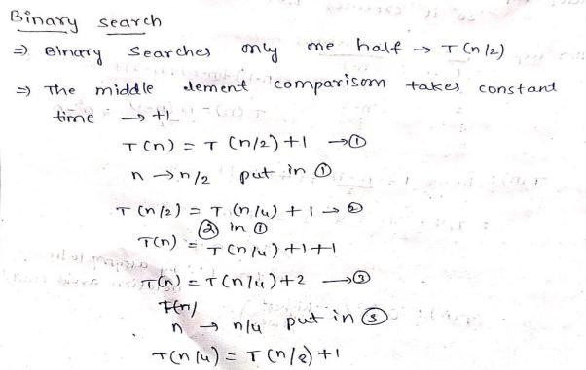



for(int i=0; i<n; i++) { cout << arr[i] << " ";
}
cout << endl;
cout << "Enter element to search: "; cin
>> key;

int result = binarySearch(arr, n, key); if(result != -1)
cout << "Element found at index " << result << endl; else
cout << "Element not found" << endl;

return 0;
}

OUTPUT:
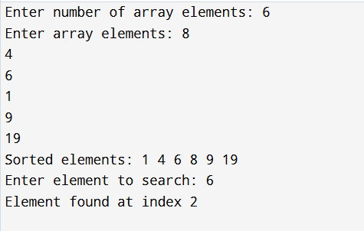

TIME COMPLEXITY:



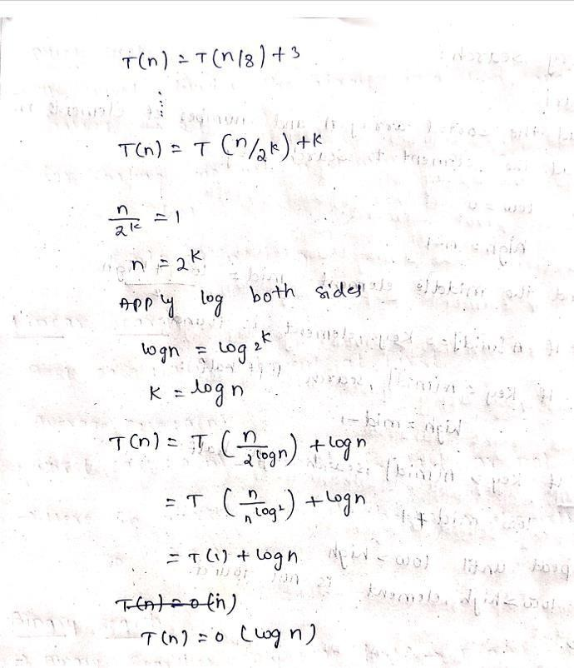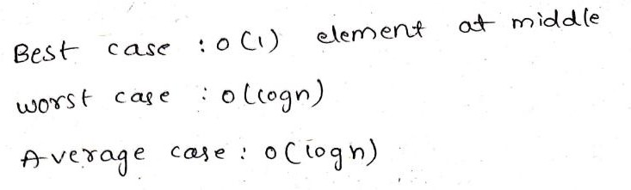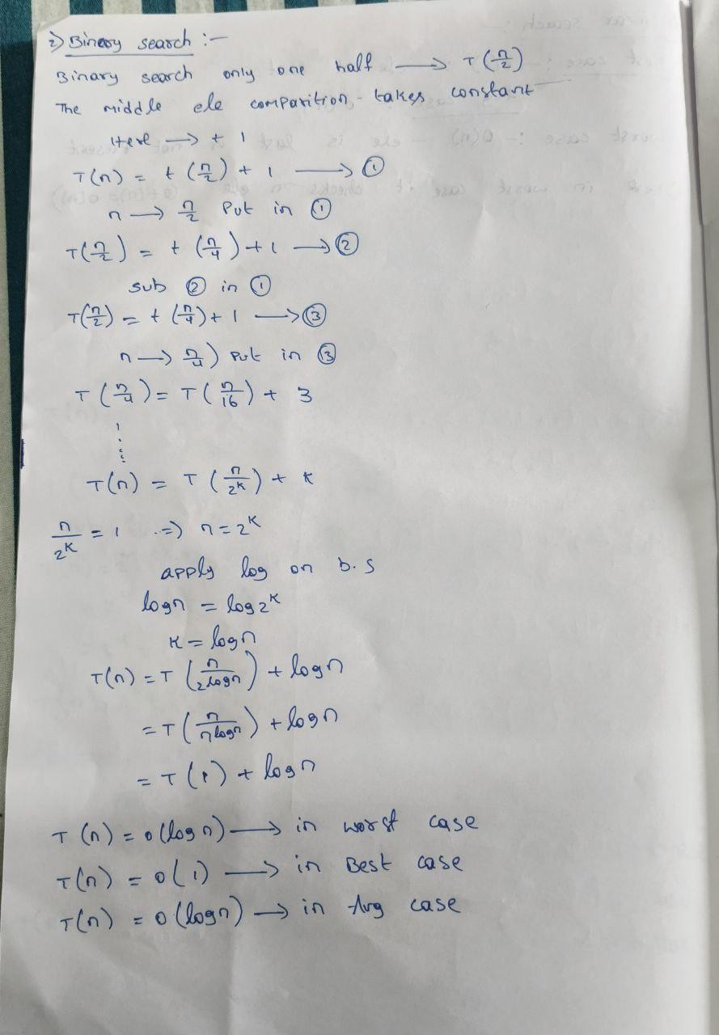

CONCLUSION:
Linear Search is simple and works on unsorted arrays but is slow with 𝑂(𝑛)time. Binary Search is much faster with 𝑂(log 𝑛)but requires the array to be sorted. For sorting, Bubble and Selection are basic 𝑂(𝑛²), Insertion improves to 𝑂(𝑛)in best case, Quick Sort is efficient on average, and Merge Sort is consistently 𝑂(𝑛 log 𝑛)though it needs extra space.

